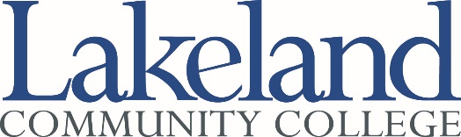
Distinguished Service Award
Nomination Form
Community Member

Presentation of Award: This award will be presented to a resident of Lake County during the
Commencement ceremony in May.

Nominations: Nominations may be made by any college employee, student or former student and should be submitted to the President’s Office, Room D-2114, by March 24, 2023.

Qualifications for Nominees: The nominee must be a Lake County resident who has made significant contributions to the College community.

Step 1: Identify the individual being nominated by typing into the fields below:

Name: Click here to enter text.

Address: Click here to enter text.

Telephone: Click here to enter text.

Step 2: Provide information about the following by typing into the fields below:

1. List contributions to the college (e.g., job-related assistance, participation in campus events, financial support, guest speaking engagements, etc.): Click here to enter text.

2. List community service (e.g., member of community organizations, offices held, participation in community events, honors or awards, etc.): Click here to enter text.

Step 3: Solicit and attach letters of support for this nomination from at least three other individuals.

Step 4: Provide contact information for the primary person submitting this nomination by typing into the fields below:

Name: Click here to enter text.
Phone: Click here to enter text.
Date: Click here to enter text.

The President’s Cabinet will forward the name of the nominee it recommends for this award to the College President.

